2-6 - Step 4 (Screenshot 1)

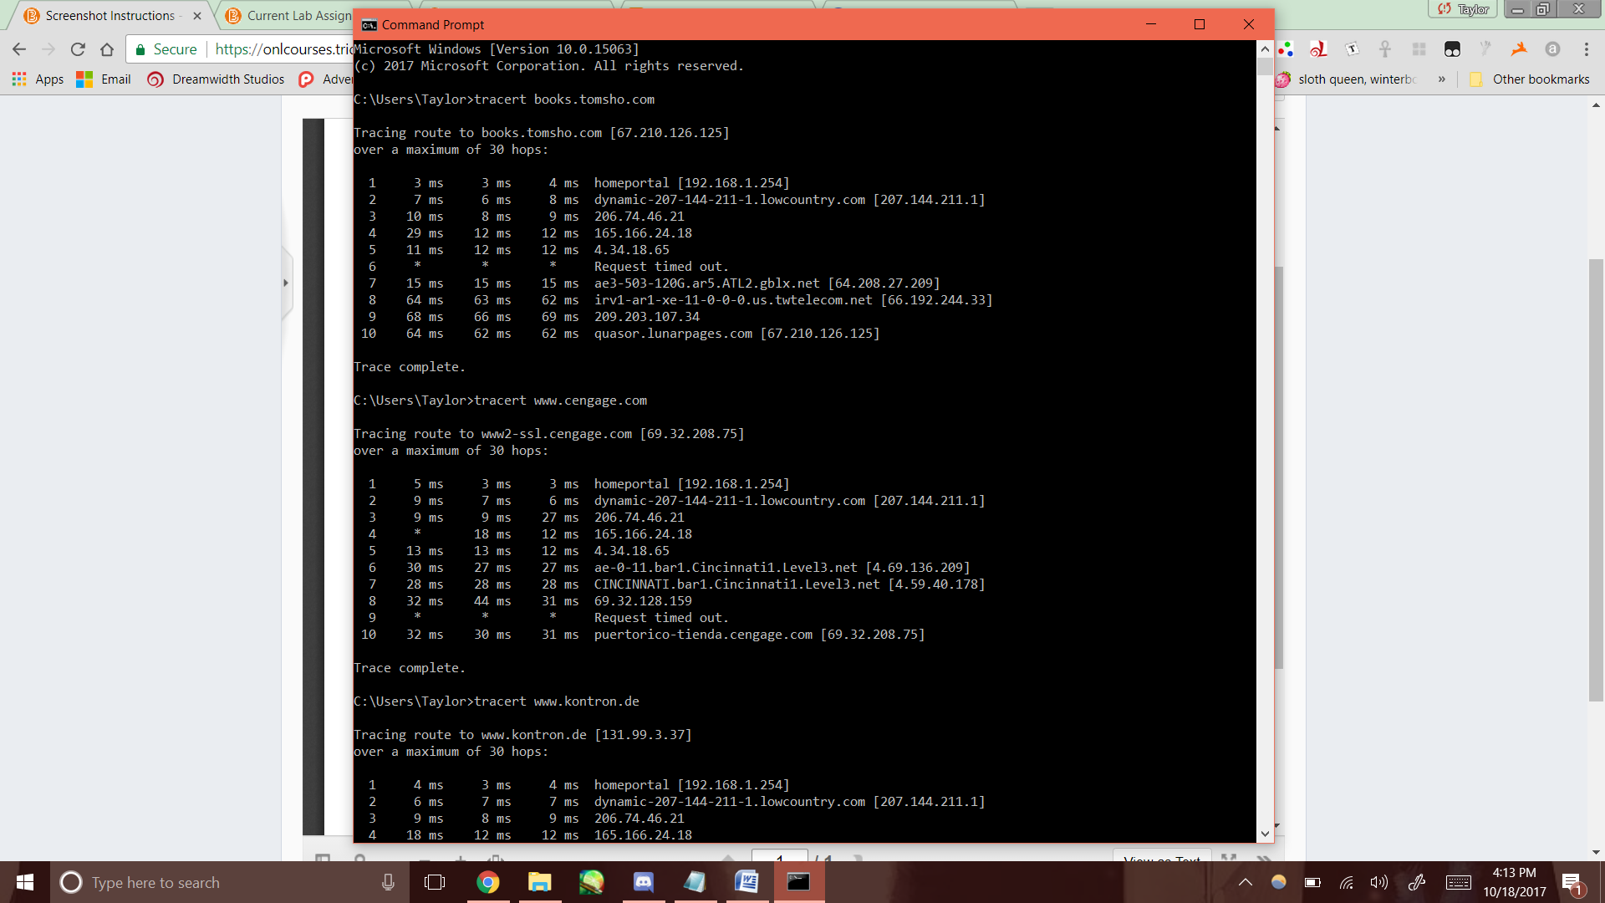

2-6 - Step 4 (Screenshot 2)

